Story behind Kanakadhārā Stotram
A long time ago, it was the practice for students to collect alms from different houses for their daily meal. One day Śaṅkara was on his rounds for bhikṣa. He reached the house of a poor lady. She was so poor that she had nothing to give as bhikṣa.
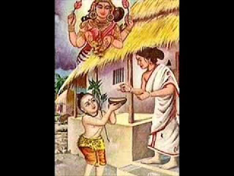

But she liked the boy so much that she did not want to send him away empty-handed. She brought a gooseberry- amalaka - from inside the house and gave it to the boy with respect and love. Her devotion touched Śaṅkara’s heart. He closed his eyes and prayed to Goddess Lakshmi. He composed a Stotra beseeching Her to shower Her grace on the poor lady. Miraculously, golden gooseberries showered into her courtyard.
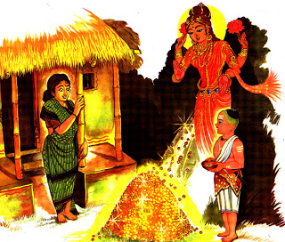
The hymn which Śaṅkara composed in praise of Goddess Lakshmi is the “Kanakadhārā Stotram”.

Source - http://krishnalacreativite.blogspot.com/2013/02/story-behind-kanakadhara-stotram.html

